Research Cost Sharing Agreement
This Research Cost Sharing Agreement (this "Agreement"), effective as of the date it is fully executed by the Parties (the "Effective Date"), is made by and between The RAND Corporation, a California nonprofit corporation with offices located at 1776 Main Street, Santa Monica, California, 90401-3208 ("RAND") and [PARTICIPATING EMPLOYER NAME], a [STATE OF ORGANIZATION] [corporation/LLC/[OTHER ENTITY]], with offices located at [ADDRESS] ("Participating Employer" and together with RAND, the "Parties", and each a "Party").
WHEREAS RAND will be conducting a research project titled “National Price Transparency Study, Round 3.0” addressing the costs incurred by employers that offer their employees self-insured health care plans (“Research”); and
WHEREAS Participating Employer has voluntarily chosen to contribute to the funding of RAND’s Research as discussed in Section 3.
NOW, THEREFORE, in consideration of the mutual covenants and agreements hereinafter set forth and for other good and valuable consideration, the receipt and sufficiency of which are hereby acknowledged, RAND and Participating Employer agree as follows:

- Research Report. Upon completion of the Research, RAND shall provide to Participating Employer an individualized research report based on the Participating Employer’s Claims Data, the general contents of which are illustrated in Exhibit A (the "Illustration of Research Report").

- Claims Data. Participating Employer shall:

  - Cooperate with RAND in its performance of the Research and instruct its third-party claims administrator to provide RAND with access to the information and documents described in Exhibit B (“Claims Data Including Protected Health Information”);

  - Take all steps necessary, including obtaining any required licenses or consents, to prevent any delays in RAND's provision of the Research Report.

- Research Contribution. The Participating Employer will contribute to the costs of RAND’s Research and offset the cost to RAND of generating the Research Report in the amount of twenty cents ($0.20) for each of Participating Employer’s average annual covered lives (including employees and dependents) whose claims information is included in the Claims Data (“Contribution”), with a minimum Contribution of one thousand dollars ($1,000.00) and up to a maximum Contribution of fifteen thousand dollars ($15,000.00) unless the Participating Employer elects a Contribution greater than that maximum. RAND will issue a Contribution invoice to the Participating Employer upon receipt of the Claims Data or when RAND has sufficient assurance that the Claims Data will be delivered. The Contribution shall be due and payable by Participating Employer upon receipt.
- Disclaimer of Warranties. RAND’S RESEARCH REPORTS ARE PROVIDED "AS IS" AND RAND HEREBY DISCLAIMS ALL WARRANTIES, WHETHER EXPRESS, IMPLIED, STATUTORY, OR OTHERWISE. RAND SPECIFICALLY DISCLAIMS ALL IMPLIED WARRANTIES OF MERCHANTABILITY, FITNESS FOR A PARTICULAR PURPOSE, TITLE, AND NON-INFRINGEMENT, AND ALL WARRANTIES ARISING FROM COURSE OF DEALING, USAGE, OR TRADE PRACTICE. RAND MAKES NO WARRANTY OF ANY KIND THAT THE RESEARCH, RESEARCH REPORTS, OR ANY PRODUCTS OR RESULTS OF THE USE THEREOF, WILL MEET PARTICIPATING EMPLOYER'S OR ANY OTHER PERSON'S REQUIREMENTS (EXCEPT AS SET FORTH IN EXHIBIT A), ACHIEVE ANY INTENDED RESULT OR BE SECURE, ACCURATE, COMPLETE, OR ERROR FREE. THE PARTIES FURTHER RECOGNIZE THAT THE ACCURACY OF RAND’S RESEARCH REPORTS, INCLUDING ANY CONCLUSIONS OR OBSERVATIONS THEREIN, IS DEPENDENT ON THE ACCURACY OF THE CLAIMS DATA RECEIVED BY RAND.
- Limitation of Liability. IN NO EVENT WILL RAND BE LIABLE UNDER OR IN CONNECTION WITH THIS AGREEMENT UNDER ANY LEGAL OR EQUITABLE THEORY, INCLUDING BREACH OF CONTRACT, TORT (INCLUDING NEGLIGENCE), STRICT LIABILITY, AND OTHERWISE, FOR ANY: (A) CONSEQUENTIAL, INCIDENTAL, INDIRECT, EXEMPLARY, SPECIAL, ENHANCED, OR PUNITIVE DAMAGES; (B) INCREASED COSTS, DIMINUTION IN VALUE OR LOST BUSINESS, PRODUCTION, REVENUES, OR PROFITS; (C) LOSS OF GOODWILL OR REPUTATION; (D) USE, INABILITY TO USE, LOSS, INTERRUPTION, DELAY OR RECOVERY OF ANY DATA, OR BREACH OF DATA OR SYSTEM SECURITY; OR (E) COST OF REPLACEMENT GOODS OR SERVICES, IN EACH CASE REGARDLESS OF WHETHER RAND WAS ADVISED OF THE POSSIBILITY OF SUCH LOSSES OR DAMAGES OR SUCH LOSSES OR DAMAGES WERE OTHERWISE FORESEEABLE. IN NO EVENT WILL RAND'S AGGREGATE LIABILITY ARISING OUT OF OR RELATED TO THIS AGREEMENT UNDER ANY LEGAL OR EQUITABLE THEORY, INCLUDING BREACH OF CONTRACT, TORT (INCLUDING NEGLIGENCE), STRICT LIABILITY, AND OTHERWISE EXCEED THE TOTAL CONTRIBUTION MADE BY PARTICIPATING EMPLOYER TO RAND’S RESEARCH UNDER THIS AGREEMENT.

- Term. The term of this Agreement begins on the Effective Date and, unless terminated earlier pursuant to this Agreement's express provisions, will continue in effect until RAND’s delivery of the Research Report to Participating Employer (“Term”).

- Termination. Either Party may terminate this Agreement, effective on written notice to the other Party, if the other Party materially breaches this Agreement, and such breach: (A) is incapable of cure; or (B) being capable of cure, remains uncured thirty (30) days after the non-breaching Party provides the breaching Party with written notice of such breach.

- Survival. This Section 8 and Sections 4, 5, and 9 survive any termination or expiration of this Agreement. No other provisions of this Agreement survive the expiration or earlier termination of this Agreement.
- Miscellaneous.
  - Entire Agreement. This Agreement, together with any other documents incorporated herein by reference and all related Exhibits, constitutes the sole and entire agreement of the Parties with respect to the subject matter of this Agreement and supersedes all prior and contemporaneous understandings, agreements, and representations and warranties, both written and oral, with respect to such subject matter.
  - Notices. All notices, requests, consents, claims, demands, waivers, and other communications hereunder (each, a "Notice") must be in writing and addressed to the Parties at the addresses set forth on the first page of this Agreement (or to such other address that may be designated by the Party giving Notice from time to time in accordance with this Section). All Notices must be delivered by personal delivery, nationally recognized overnight courier (with all fees pre-paid), facsimile or email (with confirmation of transmission) or certified or registered mail (in each case, return receipt requested, postage pre-paid). Except as otherwise provided in this Agreement, a Notice is effective only: (i) upon receipt by the receiving Party; and (ii) if the Party giving the Notice has complied with the requirements of this Section.
  - Amendment and Modification; Waiver. No amendment to or modification of this Agreement is effective unless it is in writing and signed by an authorized representative of each Party. No waiver by any Party of any of the provisions hereof will be effective unless explicitly set forth in writing and signed by the Party so waiving. Except as otherwise set forth in this Agreement, (i) no failure to exercise, or delay in exercising, any rights, remedy, power, or privilege arising from this Agreement will operate or be construed as a waiver thereof and (ii) no single or partial exercise of any right, remedy, power, or privilege hereunder will preclude any other or further exercise thereof or the exercise of any other right, remedy, power, or privilege.
  - Severability. If any provision of this Agreement is invalid, illegal, or unenforceable in any jurisdiction, such invalidity, illegality, or unenforceability will not affect any other term or provision of this Agreement or invalidate or render unenforceable such term or provision in any other jurisdiction. Upon such determination that any term or other provision is invalid, illegal, or unenforceable, the Parties shall negotiate in good faith to modify this Agreement so as to effect their original intent as closely as possible in a mutually acceptable manner in order that the transactions contemplated hereby be consummated as originally contemplated to the greatest extent possible.
  - Governing Law; Submission to Jurisdiction. This Agreement is governed by and construed in accordance with the internal laws of the State of California without giving effect to any choice or conflict of law provision or rule that would require or permit the application of the laws of any jurisdiction other than those of the State of California. Any legal suit, action, or proceeding arising out of or related to this Agreement or the licenses granted hereunder will be instituted exclusively in the federal courts of the United States or the courts of the State of California in each case located in the County of Los Angeles, and each Party irrevocably submits to the exclusive jurisdiction of such courts in any such suit, action, or proceeding.
  - Assignment. Participating Employer may not assign any of its rights or delegate any of its obligations hereunder, in each case whether voluntarily, involuntarily, by operation of law or otherwise, without the prior written consent of RAND, which consent shall not be unreasonably withheld, conditioned, or delayed. Any purported assignment or delegation in violation of this Section will be null and void. No assignment or delegation will relieve the assigning or delegating Party of any of its obligations hereunder. This Agreement is binding upon and inures to the benefit of the Parties and their respective permitted successors and assigns.
  - Counterparts. This Agreement may be executed in counterparts, each of which is deemed an original, but all of which together are deemed to be one and the same agreement.

IN WITNESS WHEREOF, the Parties hereto have executed this Agreement as of the Effective Date.

RAND, INC. | [PARTICIPATING EMPLOYER NAME]
By:_____________________  Name: __________________  Title: ___________________  Date: ___________________ | By:_____________________  Name: __________________  Title: ___________________  Date: ___________________

EXHIBIT A

Illustration of Research Report
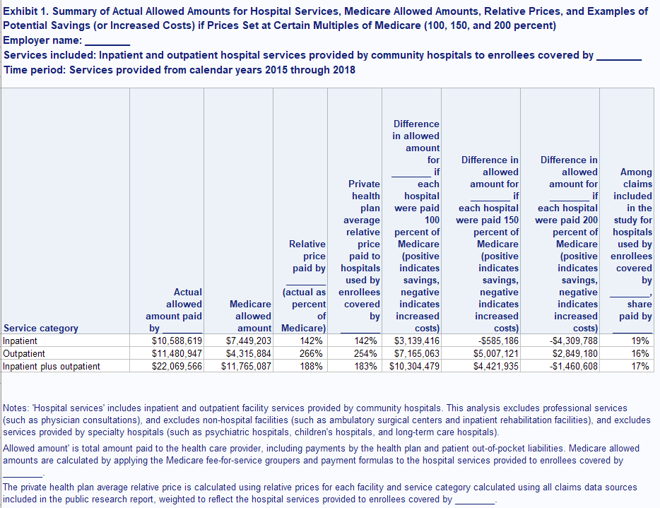
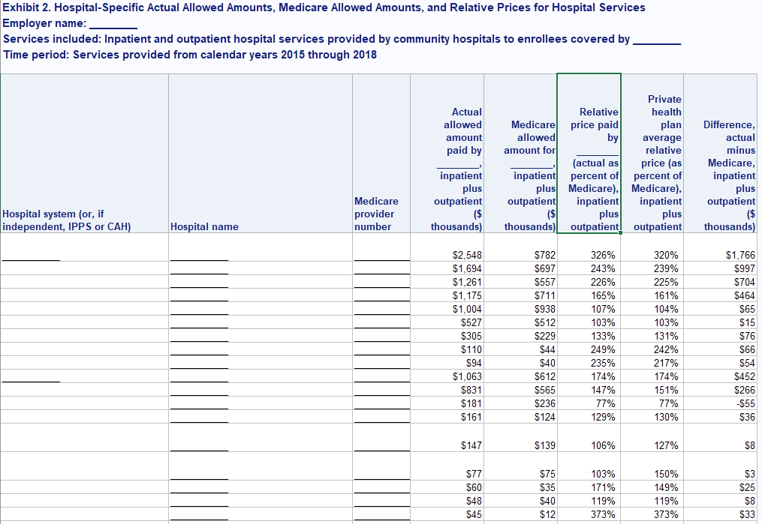

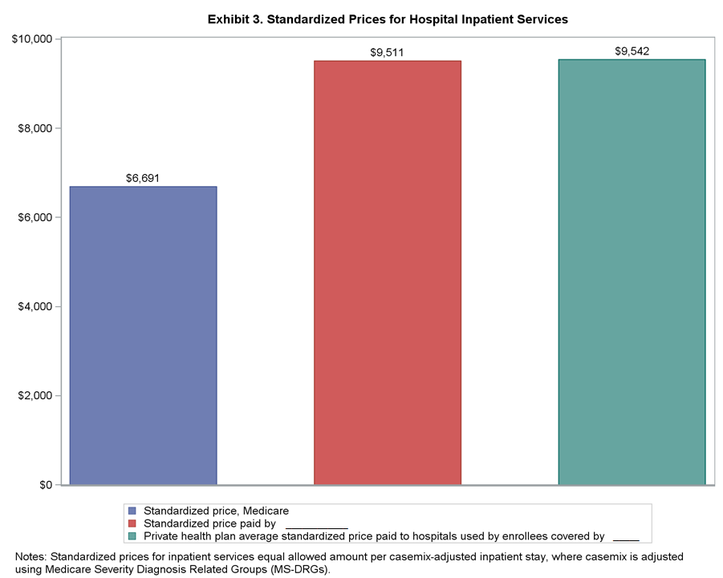
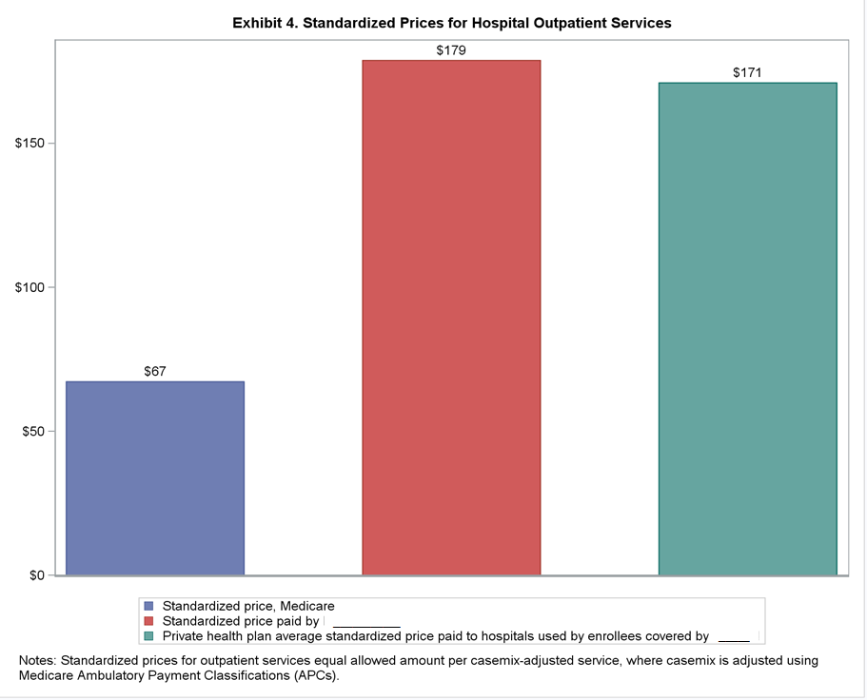

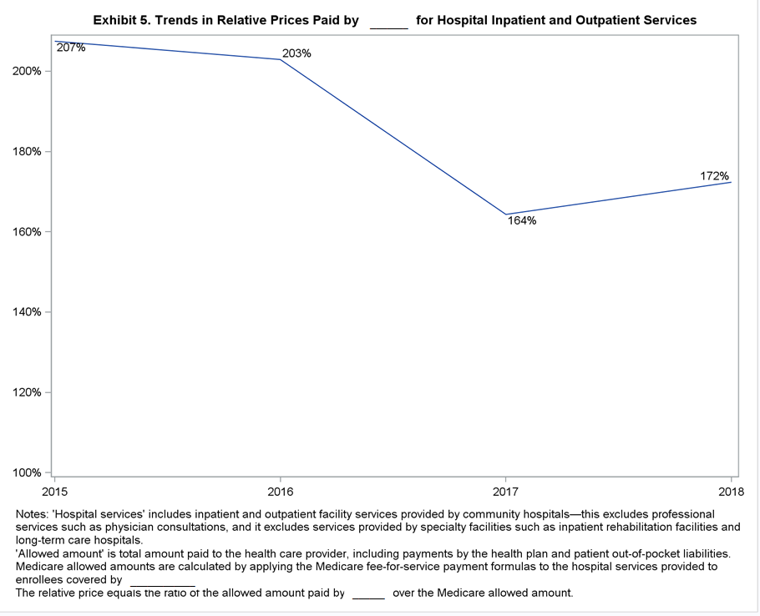

EXHIBIT B

Claims Data Including Protected Health Information
COLUMN NAME | Column Description | Notes | Considered PHI? (blank = no) (if yes, this field will be processed and removed in first step in processing) | UB-04 field (if applicable) | CMS-1500 item (if applicable)
Claim ID | A unique medical claim identifier. | Assigned by claims processor
Type of claim | Indicator for facility claim or professional claim. Facility claims are submitted using the UB-04 layout, professional claims are submitted using the CMS-1500 layout. | Assigned by claims processor
Servicing Provider Name | Either the concatenated Individual Provider First and Last Name of the servicing provider (for professional claims) or the Provider Organization Full Name of the servicing provider (for facility claims) |  |  | Field 1 | Item 32
Servicing Provider Street Address | Street address of the servicing provider |  |  | Field 1 | Item 32
Servicing Provider City | City of the servicing provider |  |  | Field 1 | Item 32
Servicing Provider State | State of the servicing provider (2-character postal abbreviation) |  |  | Field 1 | Item 32
Servicing Provider Zip | Zip code of the servicing provider |  |  | Field 1 | Item 32
Billing Provider Name | Either the concatenated Individual Provider First and Last Name of the billing provider (for professional claims) or the Provider Organization Full Name of the billing provider (for facility claims) |  |  | Field 2 | Item 33
Billing Provider Address | Street address of the billing provider |  |  | Field 2 | Item 33
Billing Provider City | City of the billing provider |  |  | Field 2 | Item 33
Billing Provider State | State of the billing provider (2-character postal abbreviation) |  |  | Field 2 | Item 33
Billing Provider Zip | Zip code of the billing provider |  |  | Field 2 | Item 33
UB04 Type of bill | Only available for facility claims. TYPE OF BILL CODE is a four-digit alphanumeric code that gives three specific pieces of information after a leading zero. CMS will ignore the leading zero. CMS will continue to process three specific pieces of information. The second digit identifies the type of facility. The third classifies the type of care. The fourth indicates the sequence of this bill in this particular episode of care. It is referred to as a "frequency" code. |  |  | Field 4
TIN | Federal tax identification number (TIN)/employer identification number (EIN) of provider | Omit if the claim is a professional claim and the provider has indicated that the TIN is an SSN |  | Field 5 | Item 25
Statement covers period from date | CLAIM STATEMENT FROM DATE represents the earliest date of service of the claim. |  | yes | Field 6
Statement covers period through date | CLAIM STATEMENT TO DATE represents the last date of service of the claim |  | yes | Field 6
Pay-to ID | PROVIDER IDENTIFIER assigned by claims processor | If claims processor has a billing provider ID (other than NPI or TIN), then please include here.
Patient identifier (encrypted) | PATIENT IDENTIFIER assigned by claims processor
Medicare Eligibility Indicator | Indicates if the member was eligible for Medicare at the time of service | Assigned by claims processor
Patient birth date | SOURCE MEMBER BIRTH DATE is the date the Member was born, as it exists in the system of record. |  | yes | Field 10 | Item 3
Patient sex | SOURCE MEMBER GENDER CODE is a code which defines the gender / sex of an individual, as it exists in the System of Record. |  |  | Field 11 | Item 3
Admission date | ADMIT DATE is the date the member was admitted to an inpatient facility. |  | yes | Field 12
Discharge date | DISCHARGE DATE is the date the member was released from an inpatient facility. |  | yes
Start date of related hospitalization | From date when a medical service is furnished as a result of, or subsequent to, a related hospitalization. |  | yes |  | Item 18
End date of related hospitalization | To date when a medical service is furnished as a result of, or subsequent to, a related hospitalization. |  | yes |  | Item 18
Type of admission/visit | ADMISSION TYPE CODE represents the priority of the admission, such as, emergency, urgent, elective or newborn. |  |  | Field 14
Source of admission | ADMISSION SOURCE CODE represents the point of patient origin for this admission or visit. |  |  | Field 15
Patient Discharge Status | DISCHARGE STATUS CODE represents the hospital discharge status code. |  |  | Field 17
Line number | The line item number for a service in a claim
From date of service | Date of service, from date |  | yes |  | Item 24A
To date of service | Date of service, to date |  | yes |  | Item 24A
Place of service | Identify the setting, using a place of service code, for each item used or service performed. |  |  |  | Item 24B
Revenue code | Industry Standard - Code used on the UB-92 (Form Locator 42) to identify a specific accommodation, ancillary service, or billing calculation related to the service being billed. The code can identify the cost center in the institution where inpatient care was provided, for example: physical therapy, surgery, room and board. | Four characters |  | Field 42
HCPCS/CPT code | Industry Standard - Medical procedure a patient received from a health care provider. Current coding methods include: CPT-4 and HCFA Common Procedure Coding System Level II - (HCPCS-II). | Five characters |  | Field 44 | Item 24D
HCPCS/CPT modifier 1 | Indicates special circumstances related to the performance of the service. For example, the 5 digit HCPCS base code if followed by 80 would indicate that an assistant surgeon delivered that service | Two characters |  | Field 44 | Item 24D
HCPCS/CPT modifier 2 | Indicates special circumstances related to the performance of the service. For example, the 5 digit HCPCS base code if followed by 80 would indicate that an assistant surgeon delivered that service | Two characters |  | Field 44 | Item 24D
HCPCS/CPT modifier 3 | Indicates special circumstances related to the performance of the service. For example, the 5 digit HCPCS base code if followed by 80 would indicate that an assistant surgeon delivered that service | Two characters |  | Field 44 | Item 24D
HCPCS/CPT modifier 4 | Indicates special circumstances related to the performance of the service. For example, the 5 digit HCPCS base code if followed by 80 would indicate that an assistant surgeon delivered that service | Two characters |  | Field 44 | Item 24D
Billed Service units | Service count, as billed. Generally, the entries in this column quantify services by revenue code category, e.g., number of days in a particular type of accommodation, pints of blood. However, when HCPCS codes are required for services, the units are equal to the number of times the procedure/service being reported was performed. |  |  | Field 46
Paid Service units | Service count, paid, generated by claims processor
Days or units | This field is most commonly used for multiple visits, units of supplies, anesthesia minutes, or oxygen volume. If only one service is performed, the numeral 1 must be entered. |  |  |  | Item 24G
Total charges | Total charges |  |  | Field 47 | Item 24F
Noncovered charges | The portion of the cost of this service that was deemed not eligible by the insurer because the service or member was not covered by the subscriber contract |  |  | Field 48
Rendering NPI | Industry Standard - The National Provider Identifier assigned to the Rendering Provider. This is the lowest level of provider available (for example, if both individual and group are available, then the individual should be provided). |  |  | Field 56 | Item 24J
Facility location NPI | The NPI of the facility if the services were furnished in a hospital, clinic, laboratory, or facility other than the patient's home or physician's office. |  |  |  | Item 32A
Billing NPI | Industry Standard - The National Provider Identifier assigned to the Billing Provider. This may represent a facility (for facility claims), a physician, a rendering provider, a group, or a billing entity. |  |  |  | Item 33A
ICD version flag | Flags ICD diagnoses and procedure codes as ICD-9 or ICD-10
Principal Diagnosis Code | PRINCIPAL DIAGNOSIS CODE represents an ICD CM Diagnosis Code identifying a condition being treated. This was replicated to Claim Line for ease of reporting. | ICD-9 or ICD-10 |  | Field 67 | Item 21.1
Other Diagnosis 1 | OTHER 1 EXTERNAL CAUSE OF INJURY CODE represents an ICD CM Diagnosis Code identifying the External Cause of Injury usually found with other Diagnosis Codes. | ICD-9 or ICD-10 |  | Field 67A | Item 21.2
Other Diagnosis 2 | OTHER 2 EXTERNAL CAUSE OF INJURY CODE represents an ICD CM Diagnosis Code identifying the External Cause of Injury usually found with other Diagnosis Codes. | ICD-9 or ICD-10 |  | Field 67B | Item 21.3
Other Diagnosis 3 | OTHER 3 EXTERNAL CAUSE OF INJURY CODE represents an ICD CM Diagnosis Code identifying the External Cause of Injury usually found with other Diagnosis Codes. | ICD-9 or ICD-10 |  | Field 67C | Item 21.4
Other Diagnosis 4 | Industry Standard - Additional diagnosis identified for this member. Decimals will be included. | ICD-9 or ICD-10 |  | Field 67D | Item 21.5
Other Diagnosis 5 | Industry Standard - Additional diagnosis identified for this member. Decimals will be included. | ICD-9 or ICD-10 |  | Field 67E | Item 21.6
Other Diagnosis 6 | Industry Standard - Additional diagnosis identified for this member. Decimals will be included. | ICD-9 or ICD-10 |  | Field 67F | Item 21.7
Other Diagnosis 7 | Industry Standard - Additional diagnosis identified for this member. Decimals will be included. | ICD-9 or ICD-10 |  | Field 67G | Item 21.8
Other Diagnosis 8 | Industry Standard - Additional diagnosis identified for this member. Decimals will be included. | ICD-9 or ICD-10 |  | Field 67H | Item 21.9
Other Diagnosis 9 | Industry Standard - Additional diagnosis identified for this member. Decimals will be included. | ICD-9 or ICD-10 |  | Field 67I | Item 21.10
Other Diagnosis 10 | Industry Standard - Additional diagnosis identified for this member. Decimals will be included. | ICD-9 or ICD-10 |  | Field 67J | Item 21.11
Other Diagnosis 11 | Industry Standard - Additional diagnosis identified for this member. Decimals will be included. | ICD-9 or ICD-10 |  | Field 67K | Item 21.12
Other Diagnosis 12 | Industry Standard - Additional diagnosis identified for this member. Decimals will be included. | ICD-9 or ICD-10 |  | Field 67L
Other Diagnosis 13 | Industry Standard - Additional diagnosis identified for this member. Decimals will be included. | ICD-9 or ICD-10 |  | Field 67M
Other Diagnosis 14 | Industry Standard - Additional diagnosis identified for this member. Decimals will be included. | ICD-9 or ICD-10 |  | Field 67N
Other Diagnosis 15 | Industry Standard - Additional diagnosis identified for this member. Decimals will be included. | ICD-9 or ICD-10 |  | Field 67O
Other Diagnosis 16 | Industry Standard - Additional diagnosis identified for this member. Decimals will be included. | ICD-9 or ICD-10 |  | Field 67P
Other Diagnosis 17 | Industry Standard - Additional diagnosis identified for this member. Decimals will be included. | ICD-9 or ICD-10 |  | Field 67Q
Present on Admission Indicator, Principal Diagnosis | POA indicator | Y=yes, N=no, U=unknown, W=undetermined, 1=exempt from POA reporting |  | Eighth digit of field 67
Present on Admission Indicator, Other Diagnosis 1 | POA indicator | Y=yes, N=no, U=unknown, W=undetermined, 1=exempt from POA reporting |  | Eighth digit of field 67A
Present on Admission Indicator, Other Diagnosis 2 | POA indicator | Y=yes, N=no, U=unknown, W=undetermined, 1=exempt from POA reporting |  | Eighth digit of field 67B
Present on Admission Indicator, Other Diagnosis 3 | POA indicator | Y=yes, N=no, U=unknown, W=undetermined, 1=exempt from POA reporting |  | Eighth digit of field 67C
Present on Admission Indicator, Other Diagnosis 4 | POA indicator | Y=yes, N=no, U=unknown, W=undetermined, 1=exempt from POA reporting |  | Eighth digit of field 67D
Present on Admission Indicator, Other Diagnosis 5 | POA indicator | Y=yes, N=no, U=unknown, W=undetermined, 1=exempt from POA reporting |  | Eighth digit of field 67E
Present on Admission Indicator, Other Diagnosis 6 | POA indicator | Y=yes, N=no, U=unknown, W=undetermined, 1=exempt from POA reporting |  | Eighth digit of field 67F
Present on Admission Indicator, Other Diagnosis 7 | POA indicator | Y=yes, N=no, U=unknown, W=undetermined, 1=exempt from POA reporting |  | Eighth digit of field 67G
Present on Admission Indicator, Other Diagnosis 8 | POA indicator | Y=yes, N=no, U=unknown, W=undetermined, 1=exempt from POA reporting |  | Eighth digit of field 67H
Present on Admission Indicator, Other Diagnosis 9 | POA indicator | Y=yes, N=no, U=unknown, W=undetermined, 1=exempt from POA reporting |  | Eighth digit of field 67I
Present on Admission Indicator, Other Diagnosis 10 | POA indicator | Y=yes, N=no, U=unknown, W=undetermined, 1=exempt from POA reporting |  | Eighth digit of field 67J
Present on Admission Indicator, Other Diagnosis 11 | POA indicator | Y=yes, N=no, U=unknown, W=undetermined, 1=exempt from POA reporting |  | Eighth digit of field 67K
Present on Admission Indicator, Other Diagnosis 12 | POA indicator | Y=yes, N=no, U=unknown, W=undetermined, 1=exempt from POA reporting |  | Eighth digit of field 67L
Present on Admission Indicator, Other Diagnosis 13 | POA indicator | Y=yes, N=no, U=unknown, W=undetermined, 1=exempt from POA reporting |  | Eighth digit of field 67M
Present on Admission Indicator, Other Diagnosis 14 | POA indicator | Y=yes, N=no, U=unknown, W=undetermined, 1=exempt from POA reporting |  | Eighth digit of field 67N
Present on Admission Indicator, Other Diagnosis 15 | POA indicator | Y=yes, N=no, U=unknown, W=undetermined, 1=exempt from POA reporting |  | Eighth digit of field 67O
Present on Admission Indicator, Other Diagnosis 16 | POA indicator | Y=yes, N=no, U=unknown, W=undetermined, 1=exempt from POA reporting |  | Eighth digit of field 67P
Present on Admission Indicator, Other Diagnosis 17 | POA indicator | Y=yes, N=no, U=unknown, W=undetermined, 1=exempt from POA reporting |  | Eighth digit of field 67Q
Admitting Diagnosis Code | ADMITTING DIAGNOSIS CODE represents an International Classification of Diseases (ICD) Diagnosis Code identifying a condition being treated, upon admission. | ICD-9 or ICD-10 |  | Field 69
Principal procedure code | Industry Standard - Principal medical procedure a patient received during inpatient stay. | ICD-9 or ICD-10 |  | Field 74
Principal procedure date | Represents the date that the corresponding procedure was performed. |  | yes | Field 74
Other procedure code 1 | Industry Standard - Other medical procedure a patient received during inpatient stay. | ICD-9 or ICD-10 |  | Field 74A
Other procedure date 1 | Represents the date that the corresponding procedure was performed. |  | yes | Field 74A
Other procedure code 2 | Industry Standard - Other medical procedure a patient received during inpatient stay. | ICD-9 or ICD-10 |  | Field 74B
Other procedure date 2 | Represents the date that the corresponding procedure was performed. |  | yes | Field 74B
Other procedure code 3 | Industry Standard - Other medical procedure a patient received during inpatient stay. | ICD-9 or ICD-10 |  | Field 74C
Other procedure date 3 | Represents the date that the corresponding procedure was performed. |  | yes | Field 74C
Other procedure code 4 | Industry Standard - Other medical procedure a patient received during inpatient stay. | ICD-9 or ICD-10 |  | Field 74D
Other procedure date 4 | Represents the date that the corresponding procedure was performed. |  | yes | Field 74D
Other procedure code 5 | Industry Standard - Other medical procedure a patient received during inpatient stay. | ICD-9 or ICD-10 |  | Field 74E
Other procedure date 5 | Represents the date that the corresponding procedure was performed. |  | yes | Field 74E
Claim status (paid as primary/paid as secondary/paid as tertiary/reversed/denied) | CLAIM DISPOSITION CODE identifies the type of claim, whether an original, reversal, adjustment or void.
In-network provider flag | Flag for whether the health plan has a network contract with service provider | Yes/No
In-network cost sharing flag | Flag for whether the claim was paid applying in-network benefits to determine the patient's cost sharing | Yes/No
MS-DRG code | DIAGNOSIS RELATED GROUP CODE represents the specific 'Diagnosis Related Group' (DRG) associated with a Claim. A DRG is a national coding scheme which classifies an inpatient stay based on diagnosis, procedure, discharge status, age and sex.
MS-DRG version | DIAGNOSIS RELATED GROUP VERSION NUMBER represents the version of the vendor Diagnosis Related Group (DRG) table. | If available, please supply here the rate year corresponding to the MS-DRG code. If not available, ok to omit. If omitted, RAND will assume that MS-DRG codes are assigned applying appropriate MS-DRG grouper based on federal fiscal year of date of discharge.
Allowed amount | Measure - The contracted reimbursable amount for covered medical services or supplies or amount reflecting local methodology for non-contracted providers.
Paid amount | Measure - The amount sent to the payee from the health plan. This amount is to include withhold amounts (the portion of the claim that is deducted and withheld by the Plan from the provider's payment) and exclude any member cost sharing.
Deductible amount | Measure - The portion of this service that the member must pay which is applied to the total period deductible. Deductibles are usually applied over a specific time period, such as per calendar year, per benefit period, or per episode of illness. Amounts should include any sanction/penalty or deductible form of insured non-compliance such as lack of prior authorizations.
Coinsurance amount | Measure - The amount the insured individual pays, as a set percentage of the cost of covered medical services, as an out-of-pocket payment to the provider. Example: Insured pays 20% and the insurer pays 80%. This amount should include member sanctions/penalties for out of network or any coinsurance form of insured non-compliance such as lack of prior authorizations.
Copay amount | Measure - Amount an insured individual pays directly to a provider at the time the services or supplies are rendered. Usually, a copay will be a fixed amount per service, such as $15.00 per office visit. Amounts should include any sanction/penalty or copay form of insured non-compliance such as lack of prior authorizations.
COB amount | An amount paid through coordination of benefits
Capitated payment flag (is this an information-only claim submitted by a provider who receives a capitated payment) | CAPITATION GROUP INDICATOR CODE is a Yes / No code used to identify a paid claim for a group with a capitated arrangement
Prepaid amount | For capitated services, the fee for service equivalent amount.
Self-insured employer account number | Account number uniquely identifies the account ID of the self-insured employer
Fully insured line of business | Insurance product type (large group, small group, individual market)

